**First solo UK exhibition of Italian designer Enzo Mari opens at the Design Museum**

**Enzo Mari curated by Hans Ulrich Obrist with Francesca Giacomelli**

An exhibition produced by Triennale Milano

29 March — 08 September 2024

Supported at the Design Museum by Istituto Marangoni

[PRESS IMAGES HERE](https://www.dropbox.com/scl/fo/lp82bonlvxfd1pws2gy9r/h?rlkey=w340e0w605l6twbc7ty5tf2jv&dl=0)

The first ever UK museum exhibition devoted to one of the most significant designers of the 20th century opens at the Design Museum on Friday.

The 60-year career of designer Enzo Mari — a pioneer of post-war Italian design — is spotlit in this major exhibition unveiled this morning. It is co-curated by Mari’s friend and collaborator, and artistic director of Serpentine, **Hans Ulrich Obrist,** with **Francesca Giacomelli**, Mari's studio project assistant, designer, curator and researcher.

The large-scale retrospective includes the full spectrum of Mari’s prolific output, from his work as a designer, but also as an artist, teacher, critic and theorist. In total, more than 300 objects are on display — most have not been seen in the UK before.

The exhibition — produced by Triennale Milano — comes to the UK after debuting in Milan in 2020. The original exhibition opened just before Mari’s death, aged 88. He is remembered as a “giant” of Italian design and a figure whose life and work has inspired generations of creatives around the world.

The vast array of works that visitors will see spans the spheres of art, design, exhibition and graphic design. Hundreds of Mari’s projects are examined, ranging from furniture to conceptual installation-based works, and from product design to graphics. Also on show are his children’s books and games, which were an important aspect of Mari’s output as in his vast creative field, he considered the needs of children just as important as those of adults.

Archival material throughout the show provides greater insight into Mari’s research process, and the key principles that guided and unified his work.

During his long career, many of Mari’s timeless designs went on to fill homes across the globe, as they continue to do to this day. They include his ‘Nature Series’ prints of apples and pears, perpetual calendars in injection moulded plastic, and timeless furniture and kitchenware.

Mari had a firm commitment to creating designs that were sustainable in both their materiality and aesthetics, and that were accessible to everyone. This approach was radical for his time, and today he can be seen as a trailblazer for many of design’s and society’s most pressing issues. His seminal instruction booklet ‘Autoprogettazione’ (Proposal for self-design), is one such example, predating open-source design practices.

Underlying much of Mari’s work was a belief that play is “the activity needed to discover one’s potential and to learn about the world”. After seeing his children playing, he decided to design new toys and games for them. These went on to become some of his most famous works, and are highlights of the exhibition. ‘16 Animals’ — which he created in 1957 — is a wooden puzzle composed of the silhouettes of sixteen animals, including a camel, elephant and kangaroo. Its production by the Milanese manufacturer Danese, proved so popular that sixteen years later Mari designed another version, ‘16 Fish’, which featured silhouettes of fish, seals, an octopus and other sea creatures. Both puzzles were intended to encourage children to discover through play. Other toys and games Mari created and on display are ‘The fable game’, and ‘The apple and the butterfly’.

Known for his uncompromising beliefs and subversive opinions, Mari has been described as ‘design’s conscience’. His stance was one of activism, calling for a greater social responsibility in design, and access to knowledge. His durable, low-cost and multifunctional objects speak to these beliefs, as do his broader installation-based works.

The exhibition has been curated by Hans Ulrich Obrist who worked closely with Enzo Mari on a series of interviews in 1990s and continued a dialogue and exchanges with him since. The exhibition is drawn from the final show Mari curated during his lifetime — *Enzo Mari: L’arte del design* at the Galleria Civica d'Arte Moderna e Contemporanea in Turin in 2008. It has been expanded to include archival material assembled by Francesca Giacomelli to illustrate the process of creation and the evolution of key projects resulting from Mari’s research.

The projects featured in the show can collectively be considered the most representative works of the nearly 2,000 Mari created during his career. The objects are displayed in chronological order, without distinguishing between disciplines, media, or types of research.

The exhibition also includes a number of tributes from contemporary international artists who reflect on Mari’s extraordinary life and legacy through site-specific installationsand new, specially commissioned works. These pieces — by Dominique Gonzalez-Foerster, Mimmo Jodice, Dozie Kanu, Adrian Paci, Barbara Stauffacher Solomon, Rirkrit Tiravanija, Nanda Vigo, Danh Vō and Virgil Abloh — make up the final section of the exhibition.

Visitors will also see a series of video interviews by Hans Ulrich Obrist that illustrate Mari’s constant ethical tensions.

In a first for the Design Museum, this major exhibition is accompanied by an additional free display on the museum’s balcony, allowing all visitors to be able to discover Mari’s enduring influence.

Thirteen London-based, contemporary designers will display select pieces of their work which demonstrate how their practice has been inspired by Mari’s thinking or his legacy. The designers are Jasper Morrison, Studiomama, Martino Gamper, Industrial Facility, Andu Masebo, Michael Marriott, Special Projects, Jaclyn Papparlardo, A Practice for Everyday Life, Rio Kobayashi, Sound Advice, Livia Lauber and StudyOPortable, and the display — titled **Grazie Enzo: Contemporary Responses to Enzo Mari** — opens on the same day as the exhibition.

**Enzo Mari curated by Hans Ulrich Obrist with Francesca Giacomelli** comes to London after its run in at Triennale in Milan in 2020, and at C-Mine in Genk, Belgium in 2023. It is curated by Hans Ulrich Obrist with Francesca Giacomelli. It is curated for the Design Museum by Rachel Hajek. The balcony display is curated by Esme Hawes.

**Hans Ulrich Obrist, curator**, said: “This is a relevant time to revisit Mari’s work and look at the issues of sustainability and accessibility through his lens. In my many conversations with him, Mari always emphasized that design objects have to be made to last for good – design that’s there to stay, against the idea of a disposable waste of resources. This connects to his passion for transformation. Form was everything for him, but he wanted to create, through these forms, models for a different society. I am delighted that the Design Museum, after successful runs in Italy and Belgium, has brought the exhibition to London and has evolved the show for UK audiences to explore the remarkable and genius world of Enzo Mari.”

**Francesca Giacomelli, curator,** said: “Mari believed that ‘*ethics is the goal of every project’*. He didn’t want to create objects, he wanted to create models for a different society, for a different way of producing and living. The aim was to have people became part of the project itself: to free the others from the passive role of consumer, because the project is not a form to contemplate or to be consumed, but an instrument of transformation that requires the active participation of a community, made aware by knowledge. His research are allegorical fragments of a single project, to which Mari has dedicated his life, in the hope "of transforming the world". Now we have the task to preserve his legacy, made of instruments of knowledge, and try to create a new world.”

**Johanna Agerman Ross, Conran Foundation Chief Curator at the Design Museum,** said**:** “The Design Museum exists to showcase the vital role designers play in society, and Enzo Mari was truly one of the design pioneers of the 20th century. His legacy and influence deserve to be more widely known, and so we are delighted to open the first ever retrospective exhibition of his work in Britain and to bring his designs and thinking to our hundreds of thousands of visitors. This is also a brilliant opportunity to investigate his legacy and influence on many contemporary designers through our balcony display that we have created as a complement to the exhibition.”

**Rachel Hajek, curator at the Design Museum,** said: “Enzo Mari’s uncompromising belief in the social responsibility of design resonates powerfully today. There is a huge amount we can learn from the ideas he championed since the 1950s onwards, and so we can’t wait to welcome visitors to explore his remarkable career.”

**-Ends-**

**Notes to Editors**

**PRESS ENQUIRIES:**

Maxwell Blowfield, Senior Media and PR Manager

E: [maxwell.blowfield@designmuseum.org](mailto:maxwell.blowfield@designmuseum.org)

Press Office

E: [pr@designmuseum.org](mailto:pr@designmuseum.org?subject=RE:%20Surrealism%20and%20Design)

#EnzoMariExhibition

@designmuseum

**Associate Sponsor:**

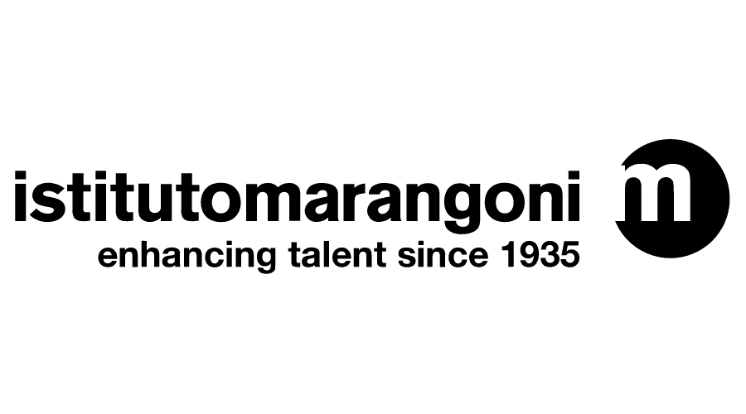

**Produced by:**

**About the Design Museum:**

The Design Museum is the world’s leading museum devoted to contemporary architecture and design. Its work encompasses all elements of design, including fashion, product and graphic design. Since it opened its doors in 1989 the museum has displayed everything from an AK-47 to high heels designed by Christian Louboutin. It has staged over 100 exhibitions, welcomed over seven million visitors and showcased the work of some of the world’s most celebrated designers and architects including Paul Smith, Zaha Hadid, Jonathan Ive, Frank Gehry, Eileen Gray, Dieter Rams, Margaret Calvert and Yinka Ilori.

On 24 November 2016, the Design Museum relocated to Kensington, west London. John Pawson converted the interior of a 1960s modernist building to create a new home for the Design Museum giving it three times more space in which to show a wider range of exhibitions and significantly extend its learning programme. Since opening in Kensington in 2016, the Design Museum has hosted major exhibitions including Stanley Kubrick: The Exhibition, Moving to Mars, Amy: Beyond the Stage, Sneakers Unboxed: Studio to Street, Electronic: From Kraftwerk to The Chemical Brothers, Charlotte Perriand: The Modern Life, Football: Designing the Beautiful Game, Waste Age: What can design do?, Ai Weiwei: Making Sense, and The Offbeat Sari.

In 2021, the Design Museum launched Future Observatory, a national programme for design research supporting the UK’s response to the green transition. The three-year programme is coordinated by the Design Museum in partnership with the Arts and Humanities Research Council (AHRC), which is part of UK Research and Innovation (UKRI).

[designmuseum.org](https://designmuseum.org/)